**Problem Set 4 Report**

Task 1

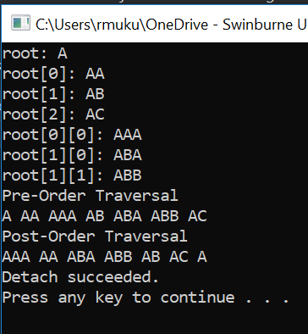

Figure 1: Output of Task 1 program

As seen in the image above, the program runs successfully. 7 nodes are created, including the root node “A”. The root node has child nodes of “AA”, “AB”, and “AC”. Child node “AA” has another child node of “AAA”. Child node “AB” has other child nodes of “ABA” and “ABB”. 2 visitor classes of pre-order traversal and post-order traversal were create to traverse through the said tree structure. The results of both traversal methods are outputted on the console.

Task 2

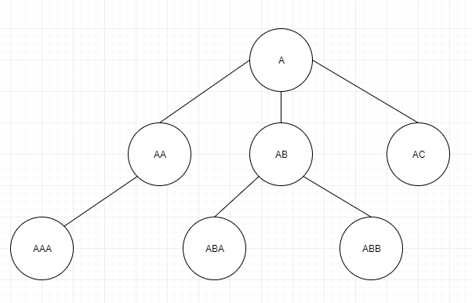

Figure 2: Tree figure of Task 1 program

|  |  |  |  |
| --- | --- | --- | --- |
| **Node** | **Depth** | **Height** | **Balance factor** |
| A | 0 | 2 | 0 |
| AA | 1 | 1 | 0 |
| AB | 1 | 1 | 0 |
| AC | 1 | 0 | 0 |
| AAA | 2 | 0 | 0 |
| ABA | 2 | 0 | 0 |
| ABB | 2 | 0 | 0 |

Table 1: Table of Depth, Height, and Balance factor of each node

Task 3

Pre-Order traversal: A, B, D, E, C, F, G, H

In-Order traversal: D, B, E, A, F, C, G, H

Post-Order traversal: D, E, B, F, H, G, C, A